Parts of Speech
In Arabic, a single word is referred to as كَلِمَةٌ (Plural: كَلِمَاتٌ). Every word in the Arabic language – whether written, spoken or read – falls into 1 of 3 exclusive categories:

- ٱسْمٌ - A noun
- فِعْلٌ - A verb
- حَرْفٌ - A particle

Book 1 concentrates heavily on ٱلْاِسْمُ. This is because nounse comprise approximately 60% to 70% of the Arabic language.

Key Properties of ٱسْمٌ

It is essential to understand that every Arabic noun possesses inherent properties regarding its gender and number.

Gender (جِنْسٌ)

In Arabic, every noun is assigned a gender. There are no neutral nouns; even inanimate objects and abstract concepts are categorised as either:

- مُذَكَّرٌ - Masculine
- مُؤَنَّثٌ - Feminine

Example Meaning Gender
كُرْسِيُّ A chair مُذَكَّرٌ
سَيَّارَةٌ A car مُؤَنَّثٌ
صَبْرٌ Patience مُذَكَّرٌ

Number (عَدَدٌ)

Arabic nouns are further categorised by the quantity they represent. Unlike English, which distinguishes only between singular and plural, Arabic identifies 3 distinct states:

- مُفْرَدٌ - Singular:
  - Refers to the singular (1) – كُرْسِيُّ
- مُثَنَّيٰ - Dual:
  - Refers to the dual (2) – كُرْسِىَّانِ
- جَمْعٌ - Plural:
  - Refers to the plural (3+) - كَرَاسِىٌّ

ٱلْدَّرْسُ ٱلْاَوَّلُ

1. Demonstrative Pronouns (هَذَا)
The 1st concept introduced is هذا. Grammatically, it is classified as ٱسْمُ ٱلْاِشَارَةِ (a noun of pointing or a demonstrative pronoun) and means “this”.

Spelling and Prononciation Rules

There is a specific orthographic rule regarding هذا that differs from its phonetics. When pronouncing the 1st letter ه, it must be streched for two counts. So it will be pronounced as ها. However, the alif is not written in standard Arabic script.

The Three Strict Conditions for Usage

هذا can only be used to point to an object if it meets 3 specific criteria:

- مَفْرَدٌ - The object must be singular
- مُذَكَّرٌ - The object must be masculine
- قَرِيْبٌ - The object must be in close proximity

Absence of the Copular

There is no “is” or “are”. When a sentence like هَذَا بَيْتٌ is written, the literal translation is “This [a] house”. To provide a grammatically correct translation, the words “is” or “are” is automatically implied. “This [is] a house”.

Vocabulary

كَلِمَةٌ | English | جِنْسٌ | عَدَدٌ
بَيْتٌ | [a] house | مَذَكَّرٌ | مَفْرَدٌ
مَسْجِدٌ | [a] house | مَذَكَّرٌ | مَفْرَدٌ
بَابٌ | [a] door | مَذَكَّرٌ | مَفْرَدٌ
كِتَابٌ | [a] book | مَذَكَّرٌ | مَفْرَدٌ
قَلَمٌ | [a] pen | مَذَكَّرٌ | مَفْرَدٌ
مَفْتَاحٌ | [a] key | مَذَكَّرٌ | مَفْرَدٌ
مَكْتَبٌ | [a] desk | مَذَكَّرٌ | مَفْرَدٌ
سَرِيْرٌ | [a] bed | مَذَكَّرٌ | مَفْرَدٌ
كُرْسِيٌّ | [a] chair | مَذَكَّرٌ | مَفْرَدٌ

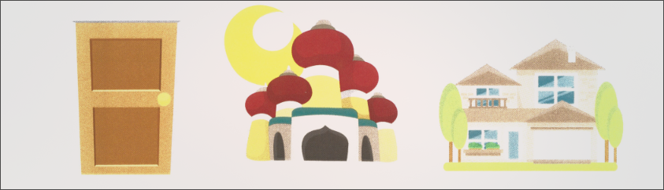
هَذَا بَيتٌ هذَا مَسْجِدٌ هَذَا بَابٌ
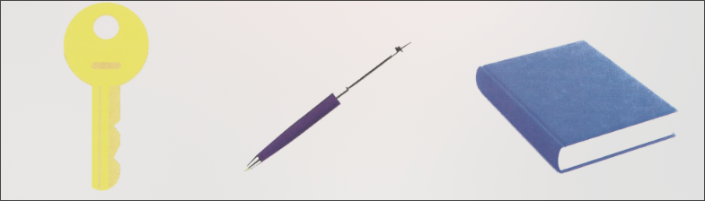
هَذَا مِفْتِاحٌ هَذَا قَلَمٌ هَذَا كِتَابٌ

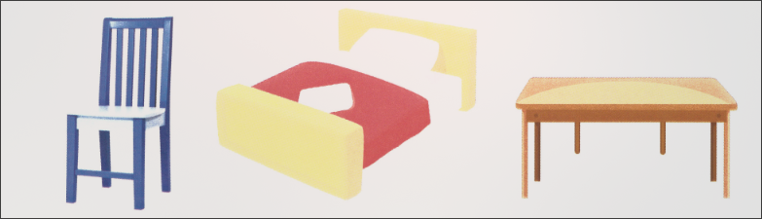
هَذَا كُرْسِيٌّ هَذَا سَرِيْرٌ هَذَا مَكْتَبٌ
2. Interrogative Arabic

In Arabic, questions are formed using specific particles (Interrogative Particles). However, before asking a question about an object, we first need to understand the 3 conditions of هَذَا used to point to it:

- مَفْرَدٌ
- مَذَكَّرٌ
- قَرِيْبٌ

(مَا)

مَا is used for non-intellect objects (غَيْرٌ عَاقِلٌ) where the identity is completely unknown. Example:

- مَا هَذَا ؟ - What is this ?

(أ)

The interrogative hamza (هَمْزَةُ ٱلْاِسْتِفْهَامِ) turns a declarative statement into a “yes/no” question.

Declaritive Statement | Interrogative Statement
هَذَا بَيْتٌ (This is a house) | أهَذَا بَيْتٌ ؟ (Is this a house)

Comparison of ما Vs. أ

Feature | ما | أ
Meaning | What ? | [Implicit “Is/Am/Are”]
Prior Knowledge | Identity is completely unknown | Speaker has a guess or suspicion
Answer Format | Requires a statement of identity | Requires a particle: نَعَمْ(yes) or لَا(no)

The Response System

When answering an “أهَذا” question you should follow these patterns:

أهَذَا بَيْتٌ؟
- لَا (No)
- لَا, هَذَا مَسْجِدٌ (No, This is a masjid)
- نَعَمْ(Yes)
- نَعَمْ, هَذَا بَيْتٌ(Yes, This is a house)

Vocabulary

كَلِمَةٌ | English | جِنْسٌ | عَدَدٌ
نَجْمٌ | [a] star | مَذَكَّرٌ | مَفْرَدٌ
قَمِيْصٌ | [a] shirt | مَذَكَّرٌ | مَفْرَدٌ

At this stage, you have to memorise the internal vowels (تشكيل)of every noun, as well as their shape. From next lesson onwards, we will not be including the vowels and you will have to learn to identify the words by their shape.
Revision is a necessity, not an option. If you cannot look at a chair, a key, or a desk and immediately name it in Arabic without hesitation, you are not yet ready for Lesson 2. Your success depends on the speed of your mental recall. Persist until it is second nature.
اقرأْ وٱلكتب

